****JINNAH UNIVERSITY FOR WOMEN

# **NUMERICAL COMPUTING**

## **CSC 3231**

## PROJECT REPORT

### BS(CS)-2020

**Submitted By:** Manal Fouad**,** Hafsa Abbasi, Mehak Dayalal & Marium Imran

**Submitted To:** Ms. Hafiza Anisa Ahmed

**Submitted On:** 13-6-2022

**STOCK MARKET SHARE ANALYSIS**

# **SUMMARY**

Stock analysis is the evaluation of a particular trading instrument, an investment sector, or the market as a whole. Stock analysts attempt to determine the future activity of an instrument, sector, or market.

Stock analysis is a method for investors and traders to make buying and selling decisions. By studying and evaluating past and current data, investors and traders attempt to gain an edge in the markets by making informed decisions.

In this report we are going to narrate stock market share analysis by using Interpolation technique and Python

Interpolation is simple mathematical method in which investors use to estimate an unknown price or potential yield of a security or asset by using related known values. By using a consistent trend across a set of data points, investors can estimate unknown values and plot these values on charts representing a stock's price movement over time.

# **CODE**

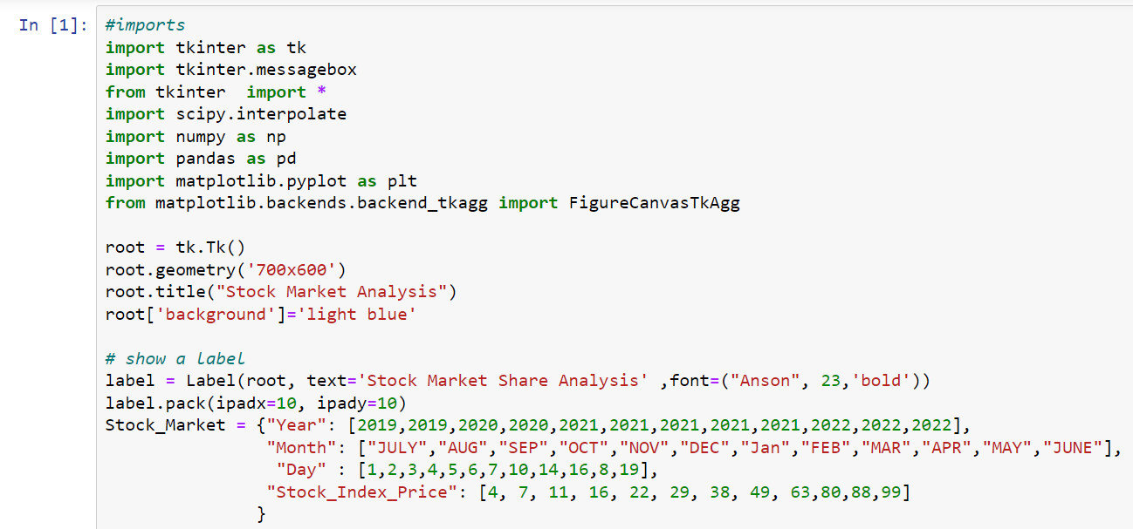

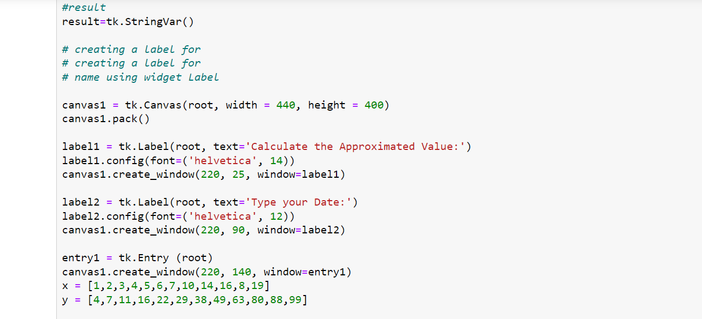

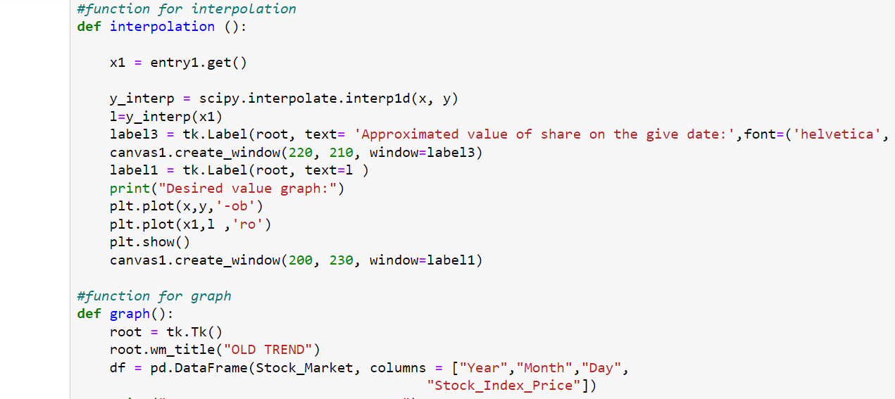

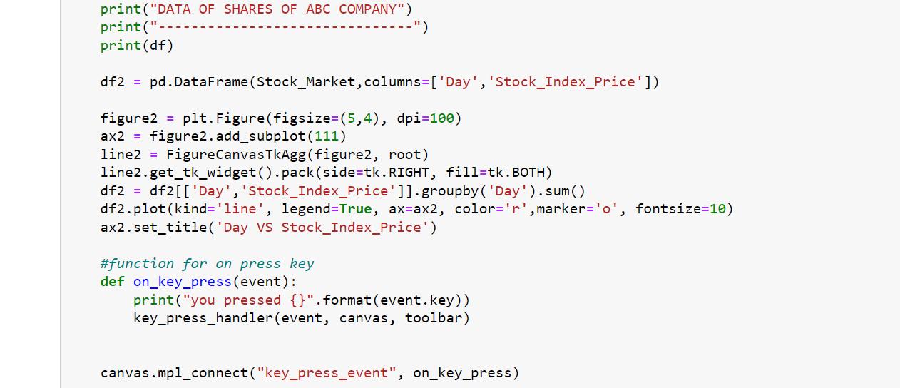

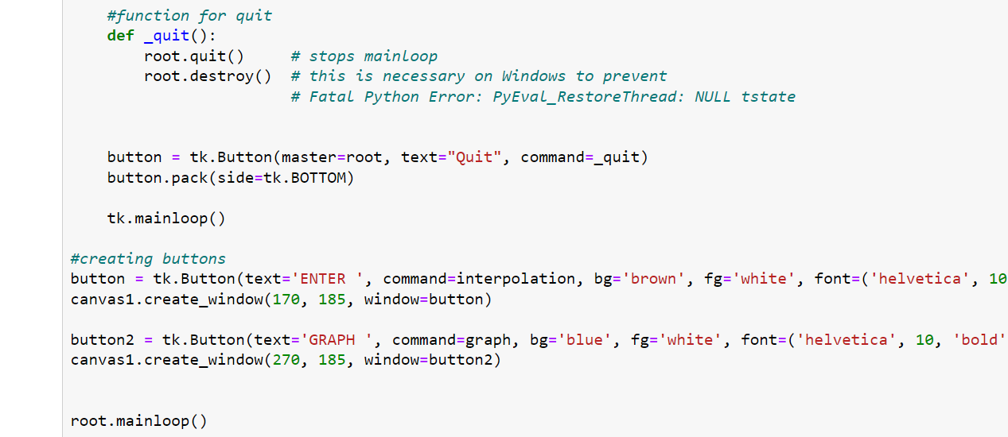

# **OUTPUT**

Main screen which requires to enter date and calculates approximated value of share on that day.

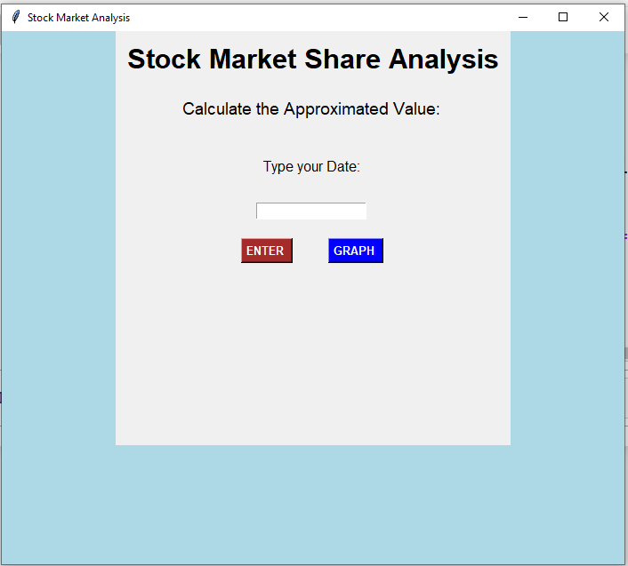

When we insert a date and press ENTER, it shows approximated value of share on given date

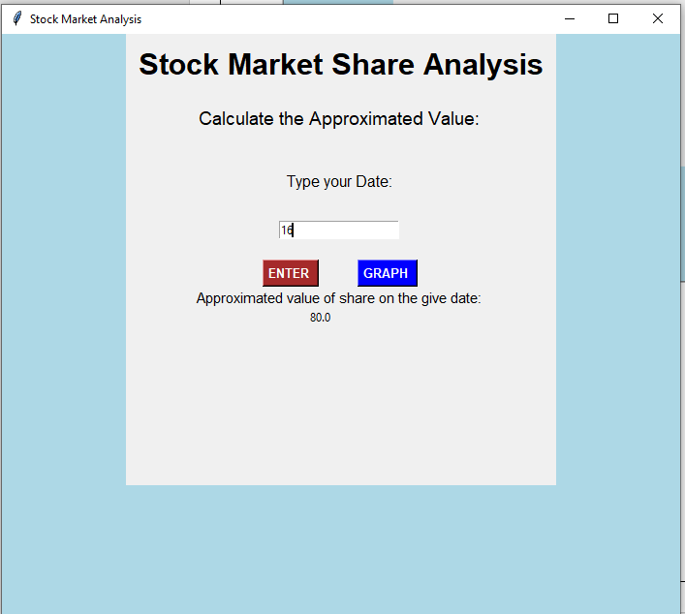

When we press GRAPH, it shows graph

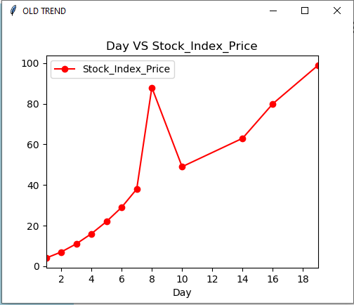

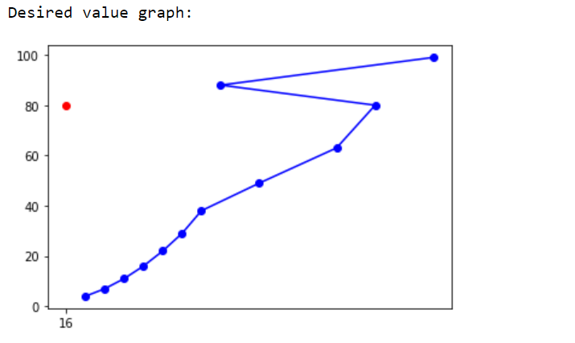

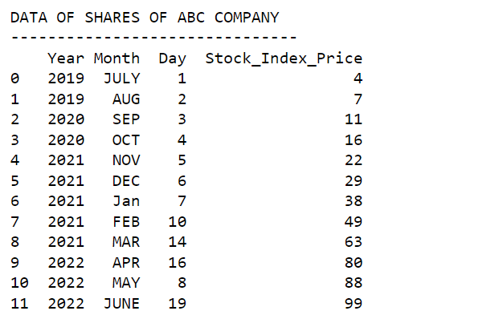

# **CODE EXPLANATION**

Data entry for Stock Market Analysis

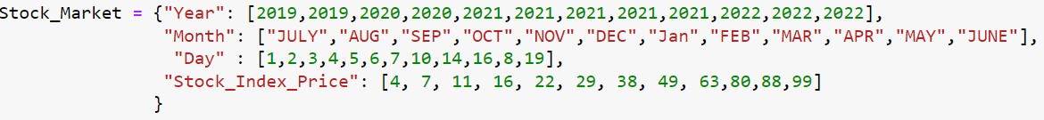

Function def interpolation() is used to find the

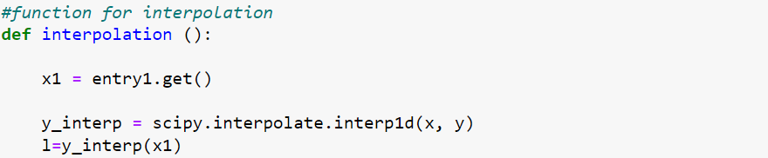

Function graph() is used to represent graph

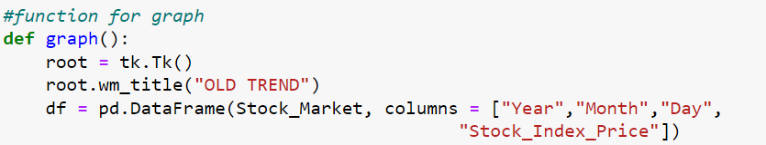

Function def on_key_press() is used to enter an value and on pressing button gives approximation of given value

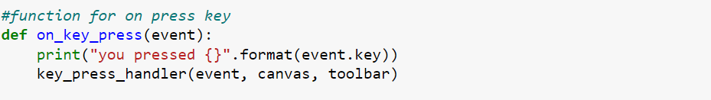

Function def quit() is used to stop mainloop

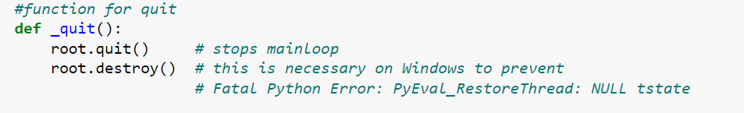

Creation of button used to compute the functions

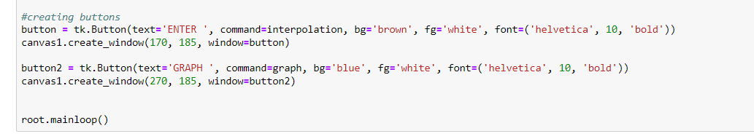

Print the the default data into the data frame.and print the graph and its other attributes.

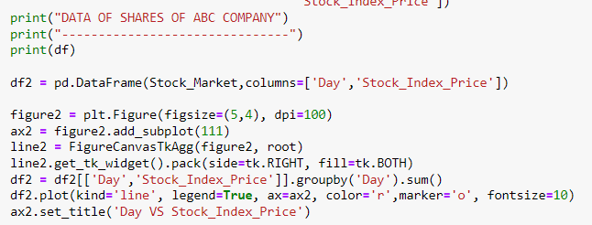

Print the graph with newly entered value and approximated value

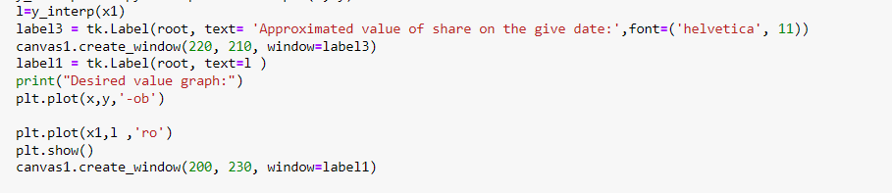

Creating labels on tkinter with entry box and its attributes.

